KARYA RANCANGAN DESAIN PAMERAN SENI RUPA VIRTUAL
Pameran Komunitas Perupa Kota Tua “LAWAN”, 10 November 2020

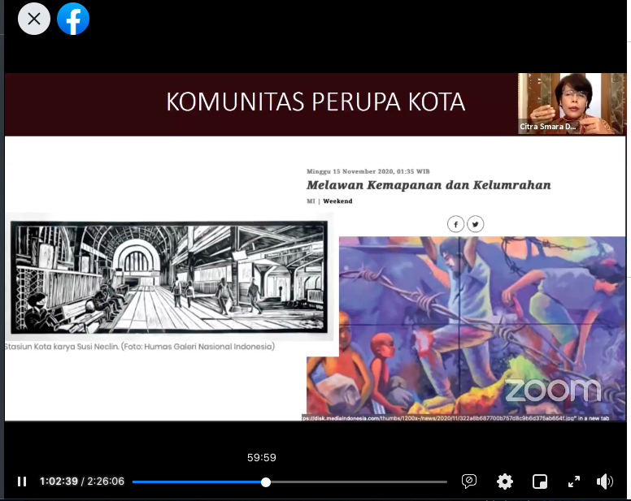

url: https://web.facebook.com/1453111504918616/videos/410391023733829

